NAME :Shaik Mohammad younoos

REG NO :192110704

COURSE :software engineering

CODE :CSA1001

FACULTY :Mary valantina

DATE :27/09/22

**LAB MANUAL 5 TO 10**

**EXPERIMENT:5**

5.Draw a USE-CASE diagram for Hospital Management System using CASE tools.

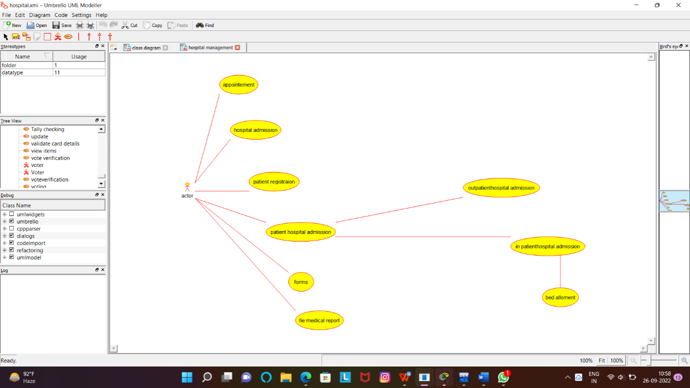

RESULT:Successfully designed this experiment using umbrello tool

**EXPERIMENT:6**

6.Draw a USE-CASE diagram for ATM System using CASE tools.

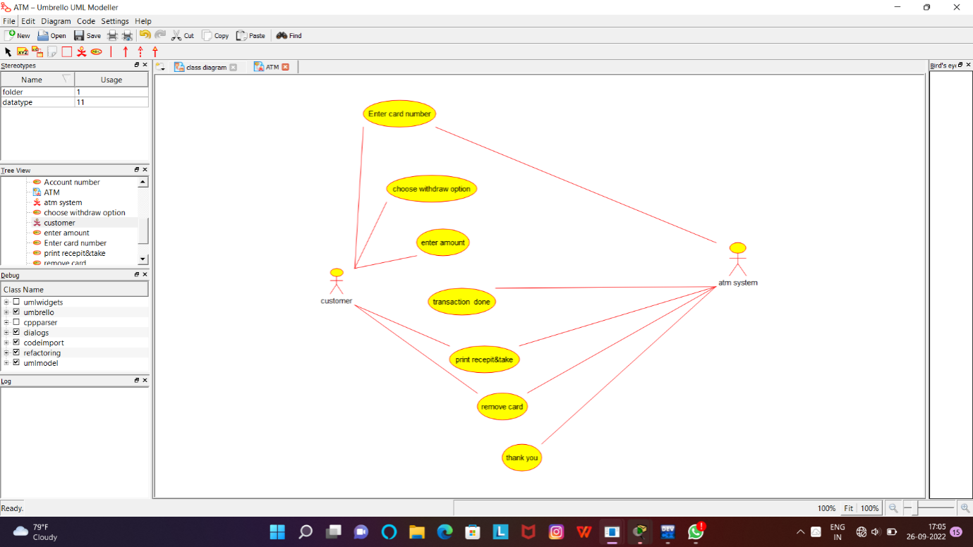

RESULT:Successfully designed this experiment using umbrello tool

**EXPERIMENT:7**

7.Draw a USE-CASE diagram for Online Shopping System using CASE tools.

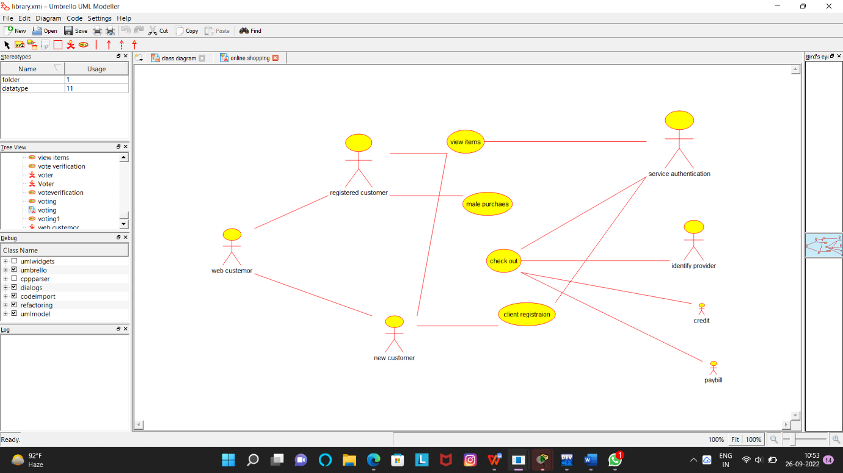

RESULT:Successfully designed this experiment using umbrello tool

**EXPERIMENT:8**

8.Draw a USE-CASE diagram for Online Airline Reservation System using CASE tools.

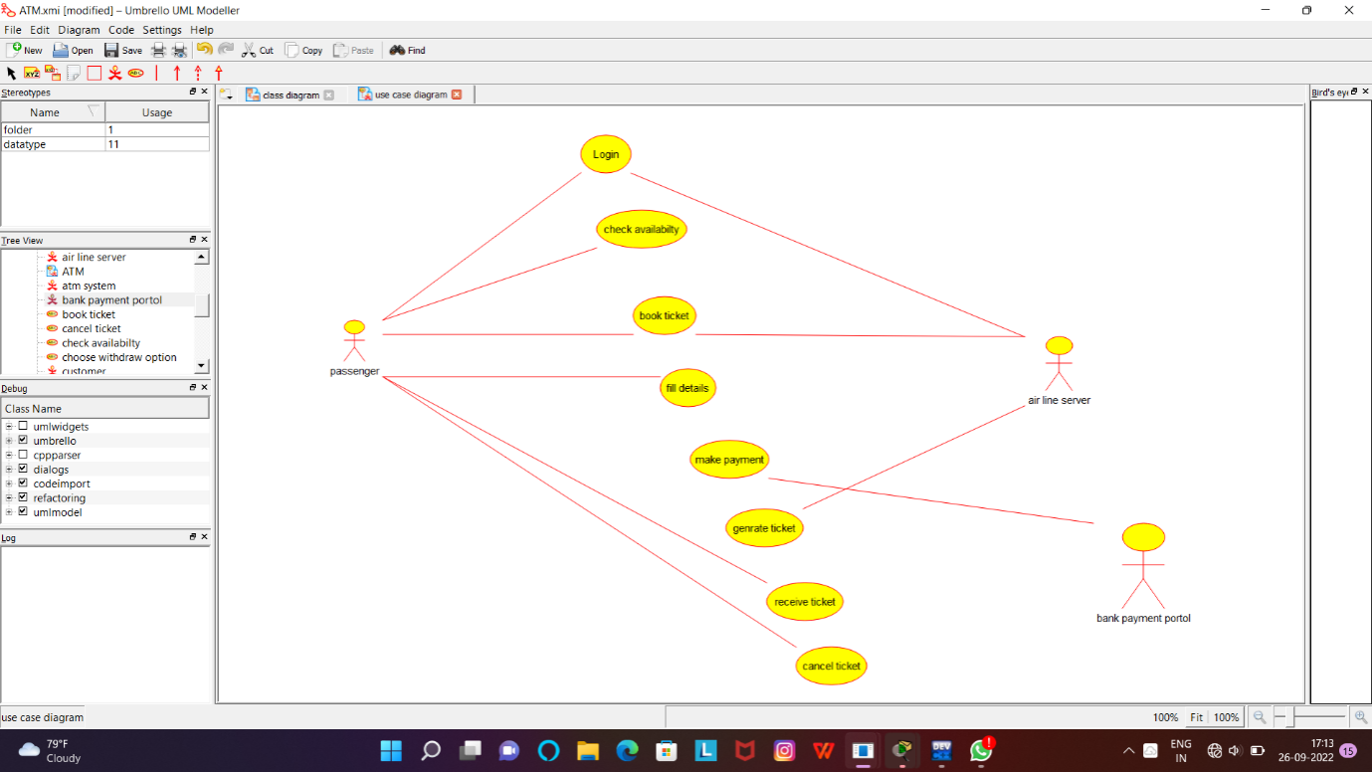

RESULT:Successfully designed this experiment using umbrello tool

**EXPERIMENT:9**

9.Draw a Class diagram for Online Airline Reservation System using CASE tools.

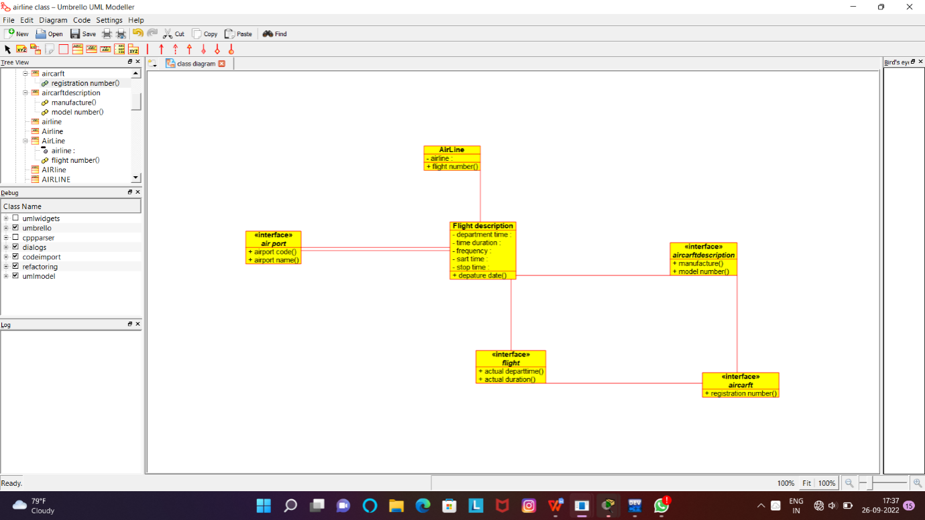

RESULT:Successfully designed this experiment using umbrello tool

**EXPERIMENT:10**

10.Draw a Class diagram for Online Voting System using CASE tools

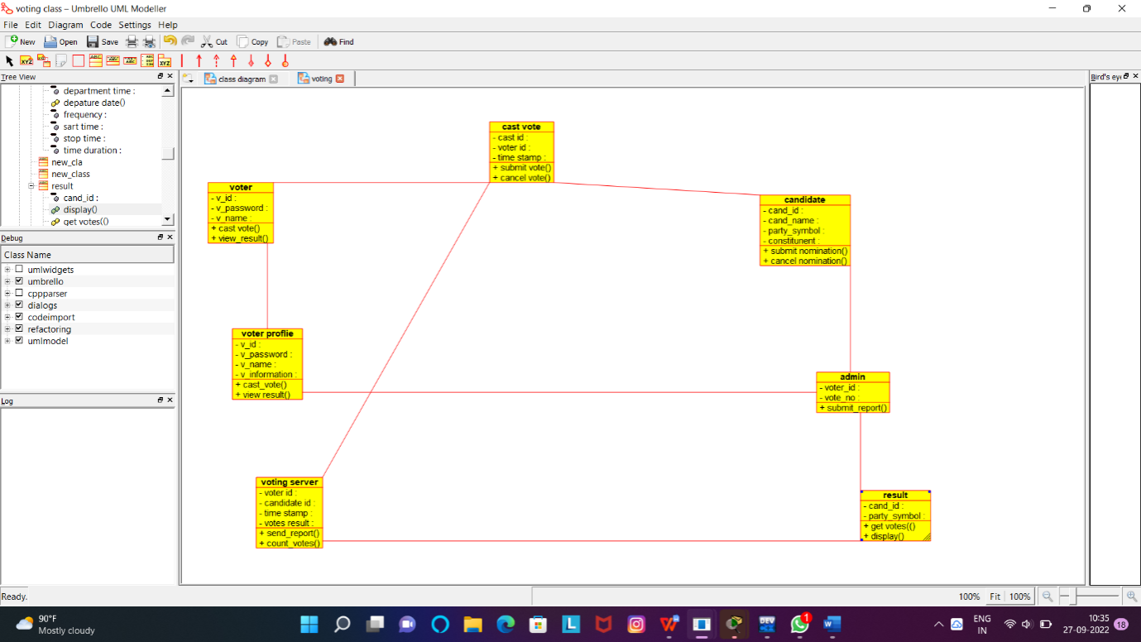

RESULT:Successfully designed this experiment using umbrello tool